**Documentation**

Name: Fit-Health app.

Aim: An app where health experts and customers could interact virtually.

Problem: We have few applications wherein we can consult a doctor online. But we have no such a platform where doctors of different specializations, yoga expert, Zumba dance fitness, meditation expert, dietician are on one platform.

Solution: Fit-Health app. Where all will be in one platform.

Abstract:

# To make quality health services affordable.

#To build a platform wherein user will connect with health experts that is doctors from all specialities, yoga expert, meditation expert, dietician, fitness expert, Zumba dance expert.

# No territorial restriction.

#Customer registration: Anybody can register.

#Health expert, pathologist registration: Registration is subjected to terms and conditions.

Types of Users

1.Health Expert:

Doctors, Fitness Expert, Nutritionist/dietician, Pathology, Yoga expert, Meditation expert, Zumba dance expert

2. Customer:

Patient, Yoga customer, Meditation customer, Diet customer, Fitness customer, Zumba dance customer

3.Admin

4. Advertisers

5. Customer care support

6. Sponsor

**Modules:**

1.Health Expert Module

#Health Experts have to first register by using mobile number.

#Once health experts are register then they will have to complete profile.

#Health experts will be assigned to customers based on either categories or health issues.

#Doctors names will be shown as per sponsorship.

#Customers can give ratings to health expert.

#Health experts can access their history and billing, appointment, consultation details through their account.

#Health experts will have unique health expert id, which will be made using combination of name, DOB.

#Doctors will be categorised as per specialization.

#Health experts will be categorised according to designation id.

# Health experts can chat with customers.

2.Customer module

# Customer will have to first register by entering mobile number.

#Once customers are register then they will have to complete profile.

#Customers will be assigned to health expert based on categories.

#Customers will be assigned to health expert as per health issues.

#Customers can give ratings to health expert.

#Customers will have unique customer id, which will be made using combination of name, DOB.

#Customers can book appointment, chat with health expert, can get health tips etc

#Customer’s health details will be saved in their Account itself. Only customer can access it. Privacy Respected.

#Customer can schedule their appointments, tests through account only.

#Refer and earn offers.

3.Admin module

#Will have responsibility to protect user data,

#Will have responsibility to assure data privacy of users.

#Will have power to remove and add any content of application.

#In matter of dispute, admin’s decision will be final.

#Will look into the functioning of application

#Sponsors and advertisers will have direct contact with admin.

#Will be dealing with Advertisers (health and fitness only)

#Admin will able to chat with health expert and customers

#Will look into queries related to payments, delay, unresponsive communication.

4. Advertisers

# Fill the form

# Advertisers will be in direct touch with Admin

#Admin’s decision in matters of advertisement will be final

# Advertisement related to health is allowed only

#Advertizers will pay decided amount

5. Customer Care Support

# 24*7 call service

#Payment issue resolution

#Complaint

6.Sponsor

#Sponsor could be individual or company.

#Health expert can be sponsors for themselves.

%Health experts and pathologists can choose their sponsor from registered sponsor.

**Functionalities:**

1.Second Page: Enter your mobile number

>About us

>Contact us

>Enter your mobile number

>Continue

2. Third page: Enter OTP

>Enter OTP

>Enter name and Surname

>Continue

3. Fourth page: Who are you?

>I am a health expert?

> I am a customer?

> I am a pathologist?

>I am a advertiser?

>Skip

4.Fifth page: Main page

>Instant video consultation

>Connect with Zumba fitness cohort

>Consult yoga expert

>Consult our dietician

>Consult with top pathologies

>Consult our meditation expert

>Offers

>Read health articles

>Consult our gym instructor

>Back to welcome page.

5. Sixth page: I am a customer? : Customer profile

>Upload photo

>Name

>View and edit profile

>Appointments

>Test bookings

>Consultation

>Health experts

>Medical records

>Schedule check up

>Payment history

>Offers

>Help Center

>Articles by health expert

>Yoga videos

>Meditation videos

>Rate and review us

>Contact us

>Log out

1.View and edit profile

>Personal

>Medical

>Lifestyle

If you click on: I am a health expert:

>Upload photo

>Name

>View and edit profile

>Appointments

>Refer test

>Medical records

>Schedule check up

>Payment history

>Articles by health expert

>Uploads

>Rate and review us

> Help center

>Contact us

>Log out

Sixth page: I am a health expert: Health expert profile

1.View and edit profile

>Remove

>Upload Picture

>Save and continue

If you click on: I am a pathologist:

>View and edit profile

>Upload Picture

>Upload owner photo

>Medical record

>Schedule check up

>Payment history

>Articles by health expert

>Rate and review

>Help center

>Contact us

>Log out

If you click on: I am a pathologist:

>Pathology photo

>Update photo

>Email ID

>Contact Number

>Emergency contact Number

>Pathology ID

> Address and pin code

>Office time

>Owner name

>Back

If you click on: I am a pathology:

>Receive call from us

2.Appointments:

For Customers: When no appointment

>Book Now

>Have a chat with our officials

For Customers: When booking appointment

>Video join link

>Click here to confirm schedule

>Click here to update

For health experts: When no appointment

>Click here to know, how can you improve your ratings

>Back

For health experts: When you have appointment

>History and billings

>Back

3.Test bookings:

For Customers: When you have no test booking

>Book Now

>Have chats with our officials

For Customers: Test booking process

>Enter city/town/village

>🡺

>Search by location

>Book now

For Customers: Test booking process. If done buy searching pathologies/tests.

>Test name

>Book now

>Back

>Search again

For Pathology:

>Back

4.Consultation:

>Paid

>Free

>Consult now

>Ask now

Consult now:

>Search health issue

>Specialities

>yoga

>Fitness guide

>Dietician

>Meditation

>Common health issue

>View all

>Symptoms relevant to you

>Zumba fitness

For fever

>Name and profile

>Language

>Offer 1

>Offer 2

>Continue

Payment

>Apply coupon code

>card

>Net banking

>UPI

>Others

>wallet

>Pay

5.Health experts

>Name and profile

>Back

6. Medical Records: For customers

>Back

>Take test

>Take appointment

Medical Records: For health experts

>Back

>History and Billings

7. Scheduled check-up: for customers

>Click here to confirm schedule

>Click here to update

Scheduled check-up: for health experts

>Back

>History and Billings

8. Payment history: for customers

>Back

Payment history: for health experts

>Back

9. Offers: for customer only

>offers given

>Back

>More offers

10. Help centre

>Search here

>Back to menu

>Not satisfied? Chat with our officials

11.Articles by health expert

>Yoga

>Meditation

>Nutrition

>Malnutrition

>Stammering

>Back

12. Yoga videos

>Back

>Click here

>Set daily yoga schedule

>Videos: step by step guide

13. Meditation videos

>Back

>Click here

>Set daily meditation schedule

>Videos: step by step guide

14. Rate and review us

>Rate us

>Write opinion

>Submit

>Refer and share

**Work flow:**

Fit-Health

1.Opening page: First look of app will be shown

2.Enter your mobile number page: After entering number, you will be navigated to OTP page.

3.Enter your OTP and name page: After entering OTP and name, you will be navigated to who are you page.

4.Who are you page: Choose your option. If skip, you will be navigated to main page.

5. Main page: Options will be given,you can choose option of your choice or else click back button.

**customer**

6. If you click on menu button, customer’s profile will be shown. Below profile, other functionalities will be given.

6. After clicking on I am a customer? You will be directed to customer profile page, here in order to get hassle free and seamless experience you will have click view and edit profile to fill your basic details.

E.g Upload photo, email id, gender, DOB, Blood group, marital status, location height, weight, contact number, customer id, emergency contact.

Same for health expert

**Health Expert**

#if click on, I am a Health Expert? it will open health expert profile.

Click view and edit profile:

>Upload photo, Name: Already Mentioned, Health expert ID, Gender, DOB, Specialization ID, Experience (Number of years), Education Qualification, Document Attachments, Academic achievements if any, Organizations you worked before, Designation ID, Nationality.

**Pathology**

#if click on, I am a pathologist? , it will open pathology profile.

Click view and edit profile:

Email ID, Contact number, Emergency contact number, Pathology ID, address, Office time, Upload photo: Owner photo and Pathology photo

**Advertiser**

#Fill the form: Name, DOB, Address, Pin code, email ID, Contact number, Advertisement purpose

#Appointments:

Customer: It will show status of appointments with health experts name, date and time. Video link will be attached green light will show that it is active.

Health experts: It will show status of appointments with customers name, date and time. Video link will be attached green light will show that it is active.

#Test bookings:

Customer: It will navigate you to list of pathologies near you, with offers.

To book test enter location. Can also book slots at pathologies by test names.

Pathology: Pathologies can see customer’s booking in detail in its account.

#Consultation: When click on consultation:

Customer can consult health expert by either paying or for free.Paid- you can have face to face online meet. Free -you can post your problems.

After clicking Consult now button, you will be navigated to health expert page.

Click on your problem. e.g fever. You will be directed to consult a doctor page. Choose language select choice of your consultation. Click on continue and Pay.

For payment – debit/credit card, net banking, upi, add money to wallet, others

Health experts can also see consultation schedule.

#Health experts: Rank according to sponsor.

#Medical records:

Customer as well as health experts can see their records in account.

#Schedule check-up:

Customer as well as health experts can see their schedule in account.

#Payment history:

Customer as well as health experts can see their payment history in account.

#Offers:

Customer will get offer

#Help centre:

Customer can get help here.

# Articles by health experts:

Customers as well as health experts can get access to articles. You can also select one among many in categories to get information about it.

#Yoga videos:

After clicking it, you can watch videos. And set schedule to meet yoga expert.

#Meditation videos:

After clicking it, you can watch videos. And set schedule to meet meditation expert.

#Rate and review:

After clicking it, you can give rate us, write your opinion about Fit-Health and also refer it to others.

**Database design:**

**user Master

|  |  |
| --- | --- |
| Type of user | User ID |
| Customer | Arjlax27111994 |
| Yoga Expert | Yogexp0001 |
| Meditation expert | Medexp0001 |
| Dietician//nutritionist expert | Dieexp0001 OR Nutexp0001 |
| Zumba dance | Zumdan0001 |
| Doctor | Doc0001 |
| Advertiser | Ramrajjainabc08061999 |

**Login:**

>Enter mobile number 🡺 Enter OTP🡺 Enter full name

> I am a customer?

> I am a health expert?

> I am a pathologist?

>I am a advertiser?

**Complete profile:**

Customer:

>Upload photo

> email id

> gender

> DOB

> Blood group

> marital status

> location height

> weight

> contact number

>customer id (primary key)

>emergency contact.

Health expert:

>Upload photo

>Name: Already Mentioned

>Health expert ID (foreign key)

> Gender

> DOB

>Specialization ID (foreign key): Could be Doctor, Dietician, Fitness Expert, Homeopathy, Ayurvedic, Physiotherapist, surgeon, Dentist, paediatrics, Oncologist, Otolaryngologist

>Experience (Number of years)

> Education Qualification

>Document Attachments

>Academic achievements if any

>Organizations you worked before

>Designation ID (primary key)

>Nationality

pathology:

* Email ID
* Contact number
* Emergency contact number
* Pathology ID (primary key)
* Address
* Office time
* Upload photo: Owner photo and Pathology photo

I am a advertiser?

#Fill the form: Name, DOB, Address, Pin code, email ID, Contact number, Advertisement purpose

**Health expert Designation and specialization ID category:**

|  |  |
| --- | --- |
| **Designation** | **Designation ID(primary key)** |
| Doctor | DOC0001 |
| **Specialization** | **Specialization ID(Foreign key)** |
| **General Physician** | Gen0001 |
| **Gynecology** | Gyn0001 |
| **Pediatrician** | **Ped0001** |
| **Ophthalmology** | **Oph0001** |
| **Dermatology** | Der0001 |
| **Gastrology** | Gas0001 |
| **ENT/ Otolaryngology** | Ent0001 |
| **Orthopedic** | Ort0001 |
| **Cardiology** | Car0001 |
| **Neurology** | Neu0001 |
| **Dentist** | Den0001 |
| **Urology** | Uro0001 |
| **Psychiatrist** | Psy0001 |
| **Diabetology** | Dia0001 |
| **Surgeon** | Sur0001 |
| **Oncology** | Onc0001 |
| **Endocrinology** | End0001 |
| **Physiotherapy** | Phy0001 |
| **Homeopathy** | Hom0001 |
| **Ayurveda** | Ayu0001 |

Health expert id:

|  |  |
| --- | --- |
| Name | Health expert ID(Foreign key) |
| Alex john smith | Alejohsmi08071985 |

Other Health experts(PK):

|  |  |
| --- | --- |
| Yoga expert | Yog0001 |
| Meditation expert | Med0001 |
| Fitness expert(gym) | Gym0001 |
| Zumba dance expert | Zum0001 |

**Wire frame design:**

1.First page

**Fit-Health**

Top health experts from all over the world now at your home



Copyrights 2022

2.Second Page: Enter your mobile number

Welcome! Enter your mobile number

About us

Contact us



+91 V

B

By continuing, you agree to our terms and condition

Continue

3.Third page: Enter OTP

Enter the 6-digit OTP sent to +91xxxxxxxxxx

Didn’t receive the OTP? Resend 00:30

ss

Surname

Middle name

Name

Enter full name

Continue

4.Fourth page: Who are you?

**Welcome! Who do you want to login as?**

**I am a health expert?**

Or

**I am a customer?**

Or

**I am a Pathologist?**

Or

**I am a Advertiser?**

to move main page

Skip

5.Fifth page: Main page

Current location: Nagpur

Our services

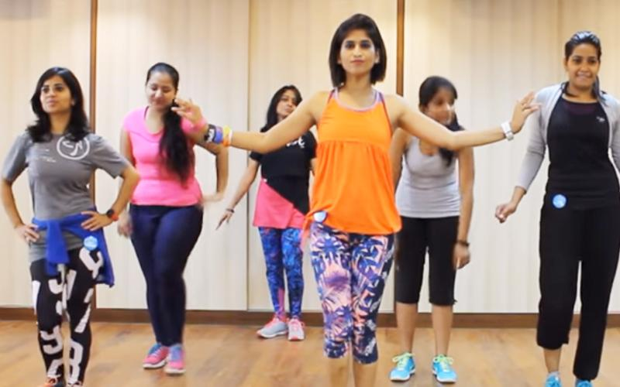





Instant video consultation

Connect with Zumba fitness cohort

Consult yoga expert





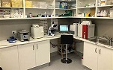

Consult our meditation expert

Connect with top pathologies

Consult our dietician



**Read health articles**

**Offers**

Back to welcome page

Consult our gym instructor

When you click menu button:

6.Sixth page: I am a customer? : Customer profile

Upload photo

**Arjun Laxane**

View and edit profile

2% completed

Appointments >

Test bookings >

Consultation >

Health Experts >

Medical Record >

Scheduled check-up >

Payment History >

Offers >

Help centre >

Articles by health expert >

Rate and review us >

Contact us >

Log out

Let’s click each and every option in menu and see what’s in there:

1. View and edit profile

Lifestyle

Medical

Personal

**Hi, Arjun Laxane**



Email id: arjunlaxane@gmail.com

Remove

Upload picture

Gender: Male

Date of Birth : 27/11/1994

Blood Group : O+

Marital Status: Single

Location: Nagpur, India

Click here to get current location

Pin code: 123456

Height(cm): 185

Weight(kg): 70

Contact Number: +91xxxxxxxxxx

Emergency contact number: +91yyyyyyyyyy

Customer ID : Arjdillax27111994

Save and continue

If you click on: I am a health expert:

Upload photo

**Doctor Alex smith**

View and edit your profile

2% completed

Appointments >

Refer Test >

Medical Record >

Payment History >

Articles by health expert >

Uploads >

Rate and review us >

Help centre >

Contact us >

I want sponsor >

Log out

.

Sixth page: I am a health expert: Health expert profile

**Hi, Doctor Alex smith**



Designation: Doctor/Fitness Expert/Yoga instructor

Remove

Upload Picture

DOB: 08-07-1985

Gender: Male

Specialization: General physician

Education Qualification: MD

Experience (Number of years): 16

Document Attachment (Upload): degrees pdf

Organisation(s) you have worked in: xyz , abc , uvz

Academic achievements if any:

Specialization ID: Genphy0001

Nationality: Indian

0

Designation ID: DOC001

Address: abc, India

Click here to get current location

Health expert ID: Alejohsmi08071985

Save and Continue

Pin code:123456

If you click on: I am a pathologist:

Upload photo

**Urmila pathology**

View and edit your profile

2% completed

Upload owner photo

Medical Record >

Scheduled check- up >

Payment History >

Articles by health expert >

Rate and review >

Help centre >

Contact us >

I want sponsor >

Log out

.

If you click on: I am a pathologist:

**Urmila pathology**



Email id: urmilapath@gmail.com

Contact Number: +91124xxxxxxx

Emergency contact: +91524xxxxxxx

Pathology photo

Update photo

Pathology ID: urmpat0001

Contac

Address: XYZ, India

Click here to get exact location



Pincode:123456

Office time: 9 AM to 7 PM

Owner: Shyam

Back

If you click on: I am a advertiser:



**Hi, Advertiser**

Name: Ram Rajesh Jain

DOB: 08-06-1999

Address: xyz, colony

Pin code: 123456

Contact number: +91eeeeeeeeee

Email ID: xyz@abc.com

Advertisement purpose: eye protection lens

Company name: abc ltd.

Advertiser ID: Ramtajjainabc08061999

Receive call from us

2.Appointments:

For Customers: When no appointment

No

Records

Available

Book Now

You haven’t booked any appointment

Can’t find any appointments?

Have a chat with our officials

For Customers: When booking appointment

**Hi, Arjun Laxane**

Customer ID: Arjdillax27111994



Your Appointments,

|  |  |  |
| --- | --- | --- |
| Name | Date | Time |
| Doctor Alex smith | 25-11-1999 | 2.00PM |

Video join link

Click here

to update

to confirm schedule

Click here

For health experts: When no appointment

**Hi, Doctor Alex smith**

Specialization ID: Genphy001

Designation ID: Doc001

Health expert ID: Alejohsmi08071985



Sorry! you have no scheduled appointment

Click here

to know, how can you improve your ratings

Back

For health experts: When you have appointment(s).

**Hi, Doctor Alex smith**

Specialization ID: Genphy001

Designation ID: Doc001

Health expert ID: Alsm08071985



|  |  |  |  |  |  |  |
| --- | --- | --- | --- | --- | --- | --- |
| Name | DOB | Customer ID | Date | Time | Medical Records | Video link |
| Radha | 25-08-1988 | Ra12345456 | 14-03-2022 | 4:00PM | Radha.pdf | Join now |
| Abdul | 25-09-1987 | Ab25469874 | 15-04-2022 | 3:00PM | Abdul.pdf | Join now |
| Krishna | 24-08-1999 | Kr23546987 | 15-05-2022 | 10.00AM | Krishna.pdf | Join now |

History and billings

Back

3.Test bookings:

For Customers: When you have no test booking

No

Records

Available

Book Now

Book Now

You haven’t booked any tests

Can’t find any tests?

Have a chat with our officials

For Customers: Test booking process



Search by location

Enter city/town/village

For Customers: Test booking process.

1.Urmila Pathology

Suyog Nagar

(45 test in just 400rs)



Book now

2.Abdul clinic

Narendra Nagar

(54 tests in just 499rs)



Book now

For Customers: Test booking process. If done buy searching pathologies/tests.

Search for tests and profiles

This test not available in your city Change City

Urinalysis Microscopy

Book now

Search again

Back

For Pathology:

**Urmila pathology**

Pathology ID: urmpat0001



Your tests,

|  |  |  |  |  |  |
| --- | --- | --- | --- | --- | --- |
| Name | DOB | Date | Records | status | Connect |
| Shyam | 12-09-1999 | 12-10-2022 | Shyam.pdf | Pending | contact |
| Ram | 12-08-2000 | 12-09-2022 | Ram.pdf | Done | contact |

Back

4.Consultation: paid

Consult our health experts

Free

Paid

Get well. Online.

Without stepping out of your home

Consult Now

Consultation: Free

Consult our health experts

Free

Paid

Ask your query?

Ask me

Consult now:

🡸 Consult our health experts

**How video consultation works?**

**Select category/health issue > Make payment > Start consultation**

Search health issues

Write something, Example: Fever, cold, yoga, Fitness tips, dietician

Choose from following categories







Specialities

Fitness guide

yoga





Meditation

Dietician

Common health issue

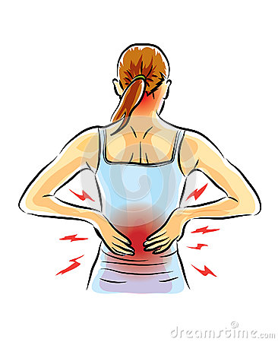

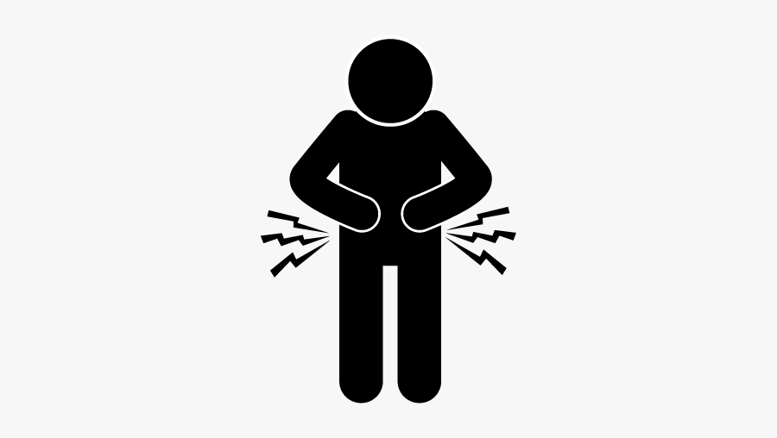

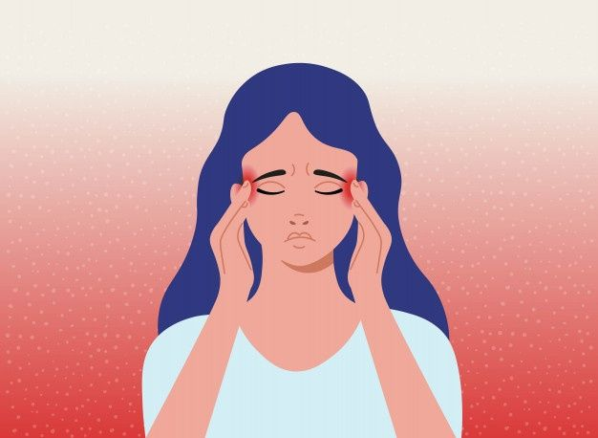

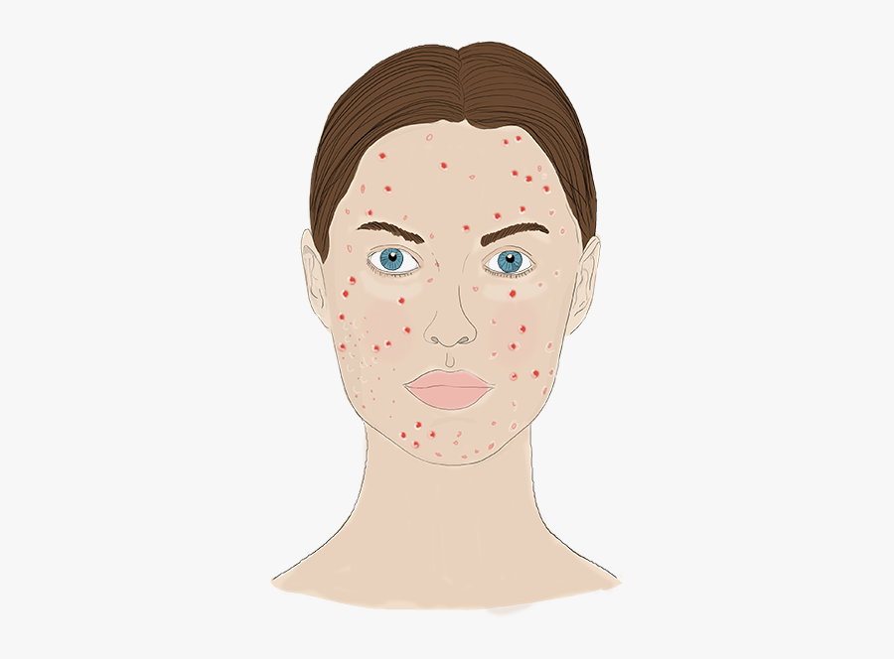

Back pain

Stomach pain

Acne

Headache



View all

Fungal infection

Symptoms relevant to you

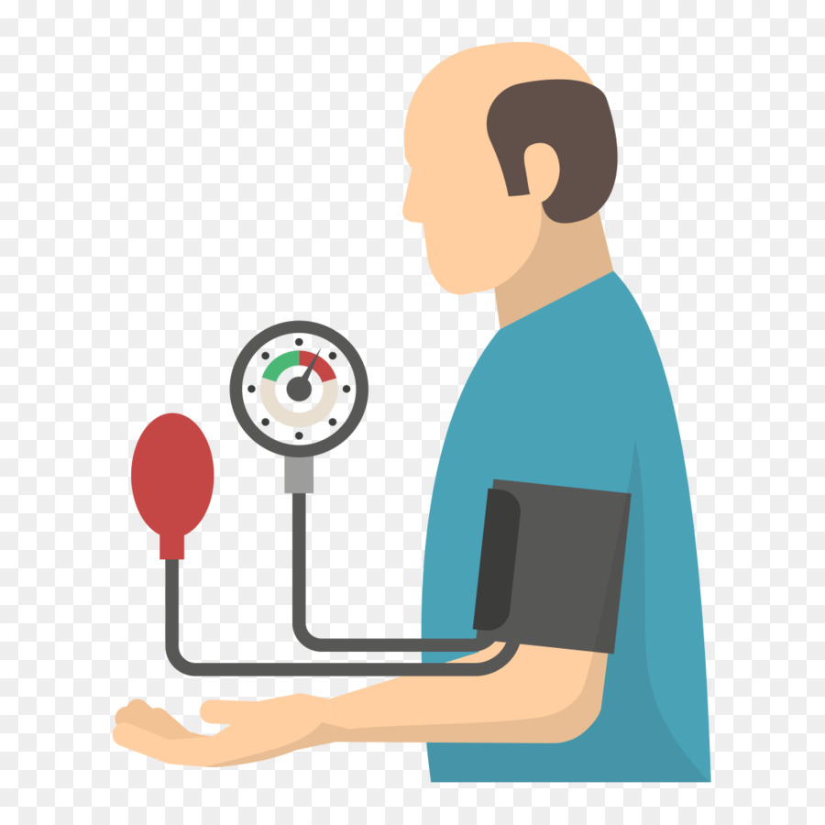





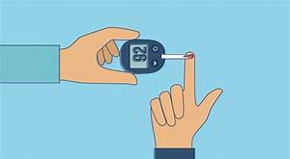

Blood pressure issue

Diabetes

Stress & Anxiety

Pregnancy

Zumba fitness



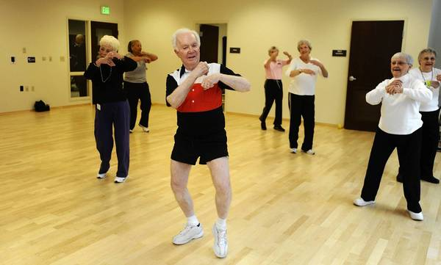



For Adults below 60

For OAP

For kids

General Physician

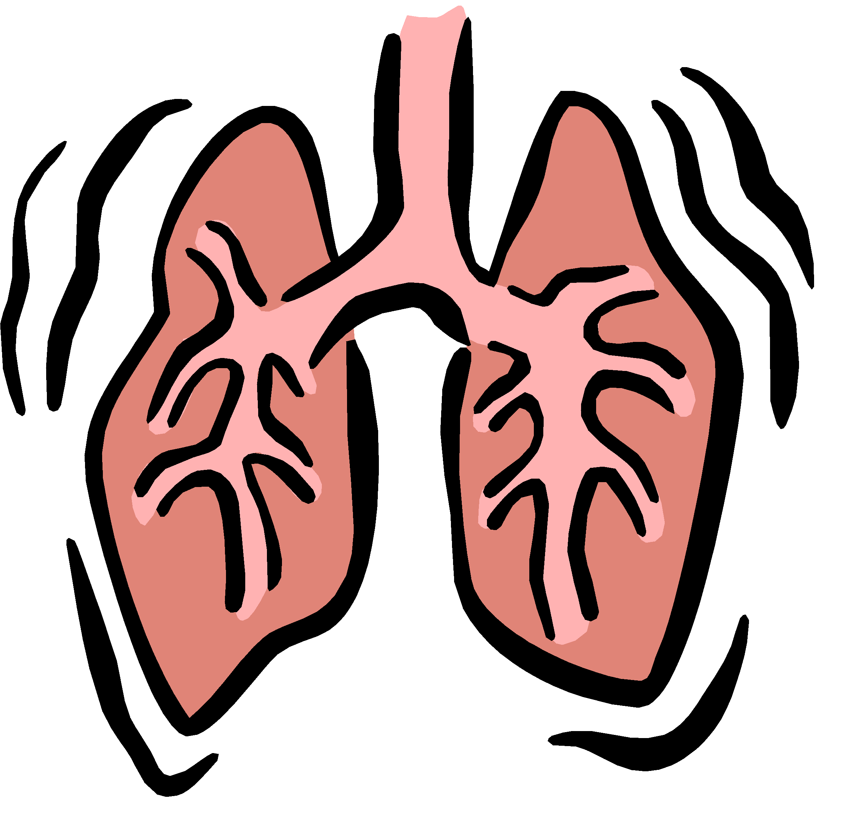



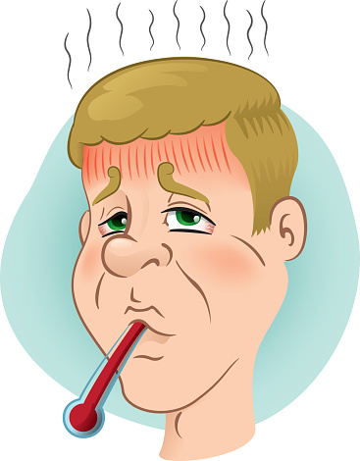

Pneumonia

Dizziness

Fever

Stammering

Talk to Speech Therapist

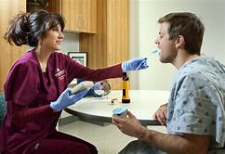



Speech Therapy for adults

Speech Therapy for kids

For Fever:

Consultation for Fever

We will assign you a top doctor from below. See online doctors

**Doctor Alex smith**

General physician

Experience : 12 years

Ratings: 4.2/5, Consultations :2000



>

Sponsored

Choose your preferred language

हिंदी

English

Single online consultation Rs.300

Chat, call , video call

*Offer*

Covers 20 consultations/month across all categories for 3 months RS.1399

* 24/7 access to health experts

Your privacy is our utmost responsibility

**Continue**

Once you click

**Continue**

Amount to pay

Rs. 300

Apply Coupon Code

Know more ?

**UPI**

**Net Banking**

**Debit / Credit card**

Others

Amazon pay, paytm ,

paypal

Add money to Wallet

Pay Rs.300

5.Health experts

Our top health experts

Sponsor

**Doctor Alex smith**

General physician

Experience: 12 years

Ratings: 4.2/5, Consultations :2000



Sponsor



**Yoga expert Nancy**

Experience : 10 years

Rating: 4.9/5, consultations:2156

Sponsor

**Dietician expert ram**

Experience : 14 years

Rating: 4.9/5, consultations:2158



Sponsor

**Zumba expert shyam**

Experience : 14 years

Rating: 4.9/5, consultations:2157

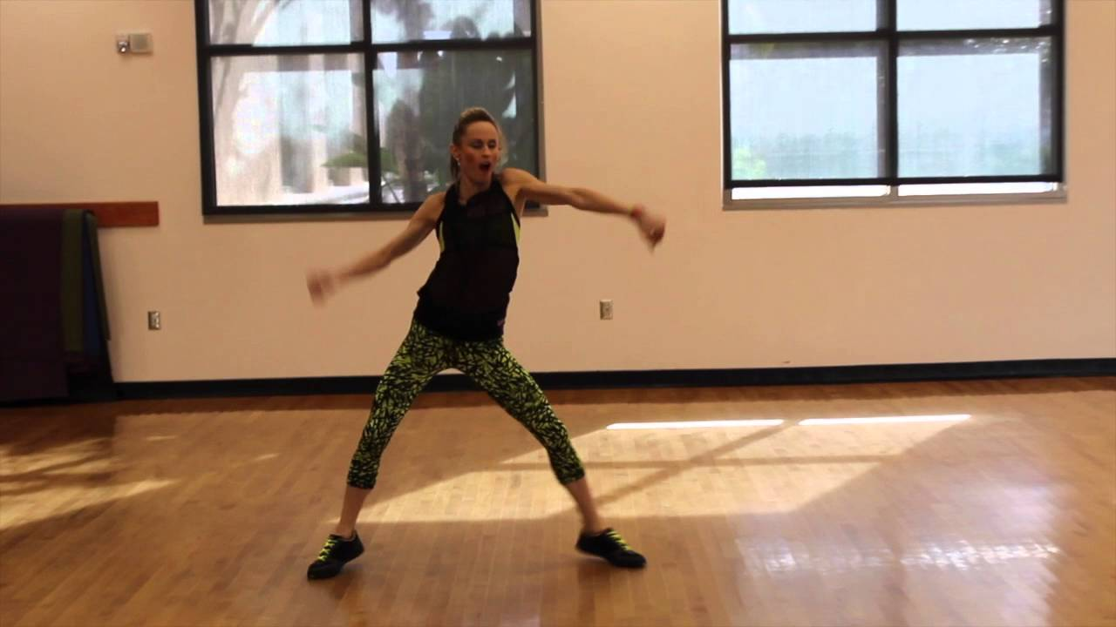

Back

6. Medical Records: For customers

Hi, Arjun Laxane

Customer ID: Arjdillax27111994



Your medical history,

|  |  |  |
| --- | --- | --- |
| Name | DOB | Time |
| Doctor Alex smith | 25-11-1999 | 2.00PM |
| Yoga expert, Radhe shyam | 27-11-1985 | 1.00PM |
| Dietician expert, suresh raina | 25-11-1989 | 10:00AM |

Take appointment

Take test

Back

Medical Records: For health experts

Hi, Doctor Alex smith

Specialization ID: Genphy001

Designation ID: Doc001

Health expert ID: Alejohsmi08071985



|  |  |  |  |  |  |  |
| --- | --- | --- | --- | --- | --- | --- |
| Name | DOB | Customer ID | Date | Time | Medical Records | Video link |
| Radha chaudhary | 25-08-1988 | Radcha25081988 | 14-03-2022 | 4:00PM | Radha.pdf | Join now |
| Abdul  khan | 25-09-1987 | Abdkha25091987 | 15-04-2022 | 3:00PM | Abdul.pdf | Join now |
| Krishna  suresh | 24-08-1999 | Krisur24081999 | 15-05-2022 | 10.00AM | Krishna.pdf | Join now |

History and Billings

Back

7. Scheduled check up: for customers

Hi, Arjun Laxane

Customer ID: Arjdillax27111994



Your Scheduled check up,

to update

|  |  |  |
| --- | --- | --- |
| Name | Date | Time |
| Doctor Alex smith | 25-11-1999 | 2.00PM |

Click here

to confirm schedule

Click here

Video join link

Scheduled check up: for health experts

Hi, Doctor Alex smith

Specialization ID: Genphy001

Designation ID: Doc001

Health expert ID: Alejohsmi08071985



|  |  |  |  |  |  |  |
| --- | --- | --- | --- | --- | --- | --- |
| Name | DOB | Customer ID | Date | Time | Medical Records | Video link |
| Radha chaudhary | 25-08-1988 | Radcha25081988 | 14-03-2022 | 4:00PM | Radha.pdf | Join now |
| Abdul  khan | 25-09-1987 | Abdkha25091987 | 15-04-2022 | 3:00PM | Abdul.pdf | Join now |
| Krishna  suresh | 24-08-1999 | Krisur24081999 | 15-05-2022 | 10.00AM | Krishna.pdf | Join now |

History and Billings

Back

8. Payment history: for customers

Hi, Arjun Laxane

Customer ID: Arjdillax1994



|  |  |  |  |
| --- | --- | --- | --- |
| Date | Time | Medical Records | Payment |
| 14-03-2022 | 4:00PM | Radha.pdf | Rs.799 |
| 15-04-2022 | 3:00PM | Abdul.pdf | Rs.525 |
| 15-05-2022 | 10.00AM | Krishna.pdf | Rs.1399 |

Back

Payment history: for health expert

Hi, Doctor Alex smith

Specialization ID: Genphy0001

Designation ID: Doc0001

Health expert ID: Alejohsmi08071985



|  |  |  |  |  |  |  |
| --- | --- | --- | --- | --- | --- | --- |
| Name | DOB | Customer ID | Date | Time | Medical Records | Payment |
| Radha  ram | 25-08-1988 | Radram25081988 | 14-03-2022 | 4:00PM | Radha.pdf | Rs.1499 |
| Abdul  khan | 25-09-1987 | Abdkha25091987 | 15-04-2022 | 3:00PM | Abdul.pdf | Rs.527 |
| Krishna | 24-08-1999 | Kr23546987 | 15-05-2022 | 10.00AM | Krishna.pdf | Rs.852 |

Back

9. Offers: for customer only

**Offers of the day**

Get full body check up at Rs. 700 only

Valid till 12.00PM, dd-mm-yyyy

Get full body check up at your home Rs. 799 only

Valid till 12.00PM, dd-mm-yyyy

Consult our top health experts at Rs. 400 only

Valid till 12.00PM, dd-mm-yyyy

Addicted to alcohol , cigarettes.

Talk to our health experts and learn ways to get rid of it.

Get 25% cash back. Valid till for 24Hrs.

Want to be fit?

Get free access to most coveted Zumba sessions for 20 days.

Hurry up!

Click here

Save 15% by

Paying via Rupay.

Does stammering makes you uncomfortable? Want to get rid of it?

Talk to our highly experienced Speech therapist

Back

More offers

10. Help Center

How can I help you?

Search here

Write something

Back to menu

Not satisfied?

Chat with our officials

11. Articles by health experts

Articles by our top most health experts

Nutrition

Meditation

Yoga

Stammering

Malnutrition

Today’s article

Back

12.Yoga videos

Want to know about yoga?

Click here

Set daily yoga schedule

Videos

Step by step guide

Back

13. Meditation videos

Want to know about meditation?

Click here

Videos

Step by step guide

Set daily your meditation schedule

Back

14. Rate and review us

5 star

Rate us

Write your opinion about FitHealth

Refer and share

Submit